ESP32 Pins
Pin3 Up button
Pin4 Down Button
Pin5 Mode Button
Pin6 Start Button
Pin8 I2C SDA
Pin9 I2C SCL

ESP32 S3 Zero
https://www.waveshare.com/wiki/ESP32-S3-Zero
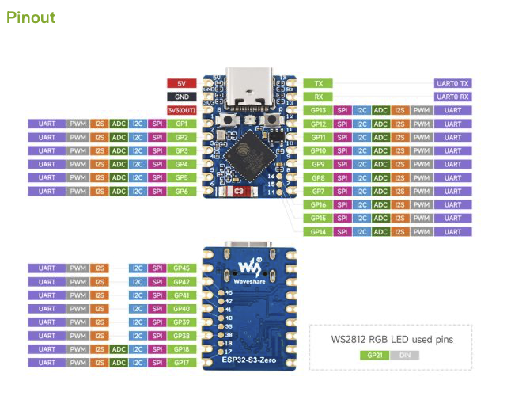

Motor Driver Tutrial
https://www.makerguides.com/a4988-stepper-motor-driver-arduino-tutorial/
A4988 Stepper Motor Controller
https://www.pololu.com/product/1182

Stepper Motor code
https://randomnerdtutorials.com/esp32-stepper-motor-28byj-48-uln2003/

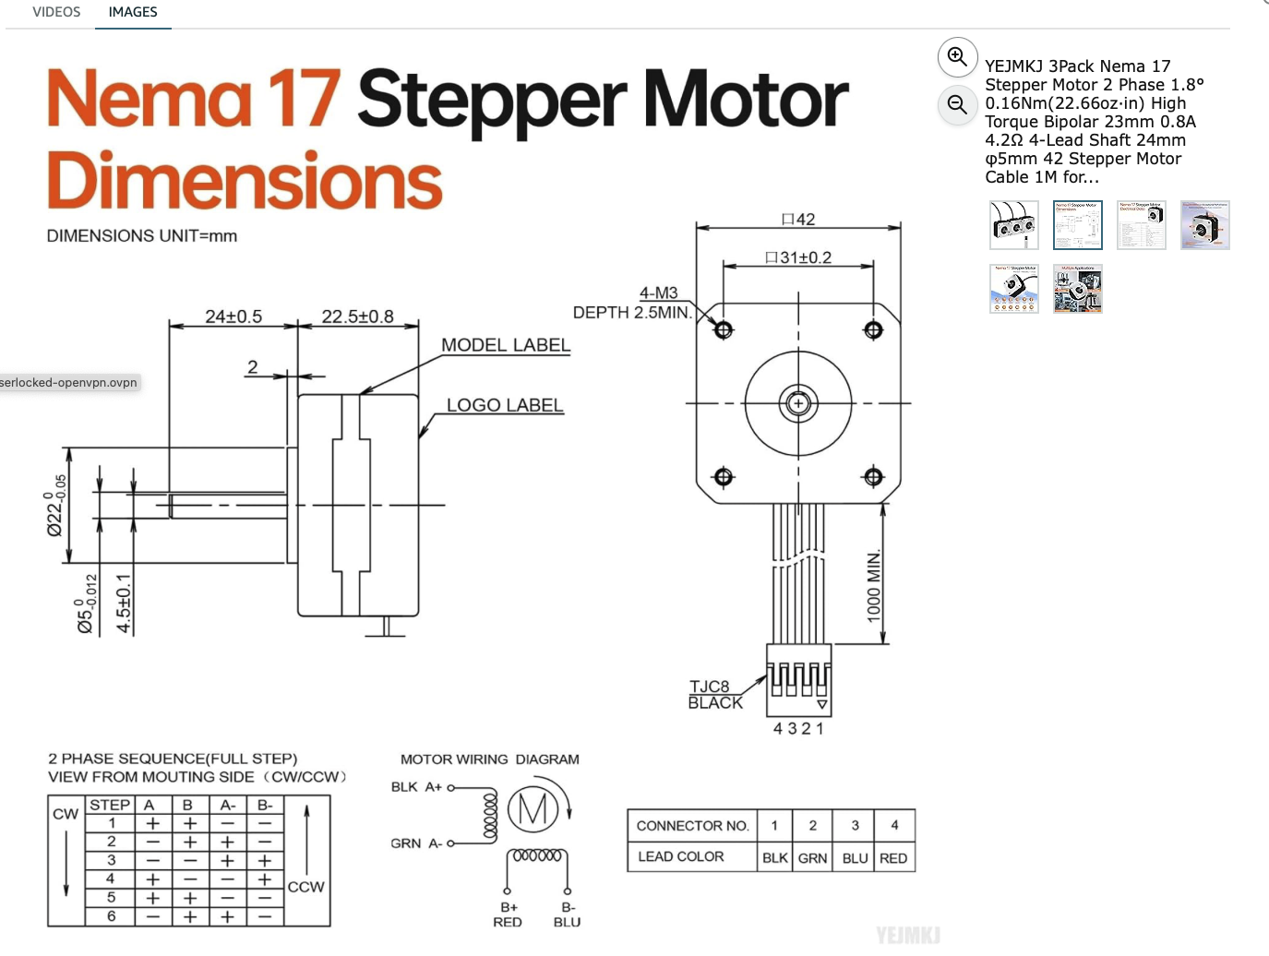
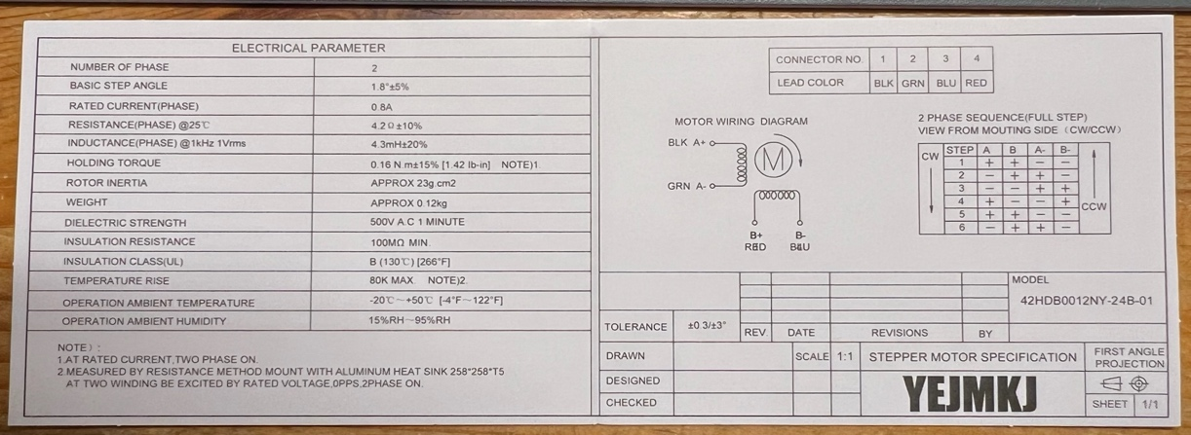
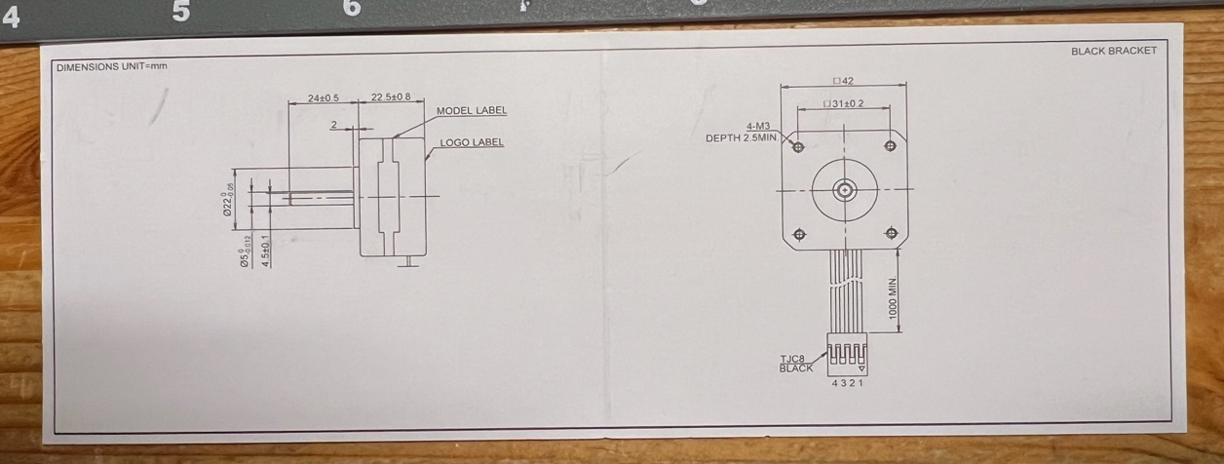

Beep
https://docs.sunfounder.com/projects/esp32-starter-kit/en/latest/arduino/basic_projects/ar_ac_buz.html

